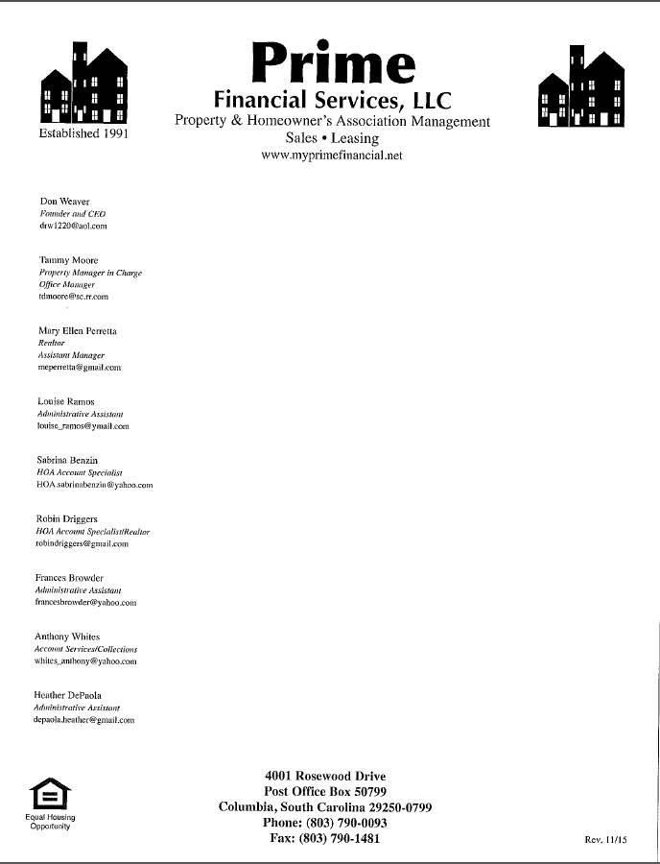

To: All HOA Representatives

From: Don Weaver

Date: November 26th, 2012

Re: Prime’s Policy on Violation Letters

As of January 1st, 2013, Prime Financial’s policy will be to charge a fee of $25.00 per violation letter to the HOA which has requested the letter. The fee will be paid by the HOA to Prime at the time that the letter is mailed. The fee will then be billed to the homeowner’s account who received the letter.